Press Release: Poliquin and Collins Leave Mainers Out in the Cold 12/18/2017

Tuesday between 8 AM and 2 PM Mainers will stand in front of the federal building with a banner that makes plain what Bruce Poliquin and Susan Collins have done.

In November, Bruce Poliquin along with 226 Republican colleagues passed the House tax bill. Susan Collins then provided the critical vote to enable Senate passage of the tax bill by a purely partisan 50 Republican votes. In December she provided another critical yes vote to approve the bill in the Senate.

Above all else, this legislation will transfer 1.5 trillion dollars from the U.S. Treasury to the wealthiest private pockets and corporate coffers. The lion’s share of each goes to the very wealthiest families and to the very largest corporations.

500 billion dollars will go to individuals. Half of this money will go to the top one percent. And the wealthiest of the wealthiest (the top 0.1%) will receive half of that.

One trillion dollars will go to businesses, most to the largest corporations. The promise is that corporations will invest their gains and create new jobs. History teaches otherwise: Most of this windfall will be likely be passed on to stockholders as profits.

Who will reap those profits? Stock market facts: The wealthiest 1% of families own 38% of stock market wealth. The bottom 80 percent own 8 percent. Half of Americans own zero stock.

Bottom line: This tax bill’s primary beneficiaries are the political donor class To pretend otherwise insults our common sense and denies what we’ve seen happening in plain sight.

Last minute improvements that Sen. Collins says she’s helped secure are not trivial. But they are dwarfed by the impact of taking 1.5 trillion public dollars and putting them into private pockets. This raid on the treasury portends cuts to Medicare, Medicaid, Social Security, food stamps, public housing, public education, public transportation, infrastructure repair, student scholarships, and lost access to healthcare despite Collins’ band-aid bill, even if it survives. Cuts to government programs that Mainers depend on vastly outweigh any benefit.

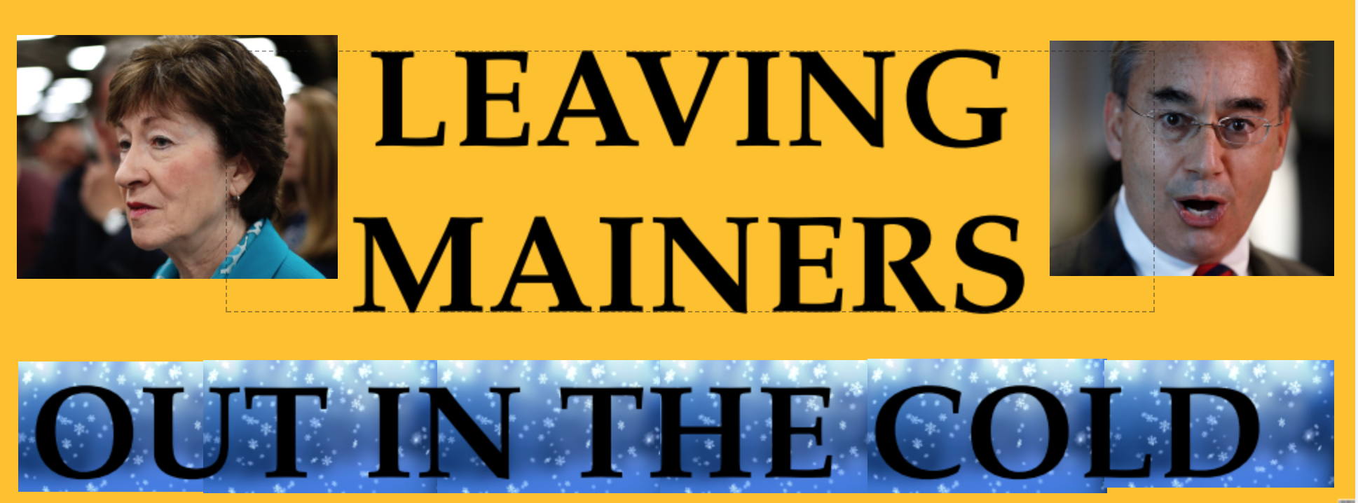There is reason to think that a stimulated economy will produce more jobs and some additional revenue. That is why the most optimistic non-partisan estimates suggest the final deficit will be closer to one trillion rather than $1.5 trillion.. But the claim that these cuts will pay for themselves is fairy dust that clouds no eyes except those of true believers . With their votes, Poliquin and Collins have bet Mainers’ basic well-being on their belief in trickle-down economics

Collins also banks on the reassurances she received from Republican party leaders in return for her vote. Good luck with that. Here’s one for starters:

Dec. 3, Susan Collins on Meet the Press: “And I also got an ironclad commitment that we're not going to see cuts in the Medicaid/Medicare program as a result of this bill”

Dec. 6, Washington Post: “Ryan says Republicans to target welfare, Medicare, Medicaid spending in 2018”

Bruce Poliquin and Susan Collins have both voted in lockstep with all their Republican colleagues to further enrich America’s wealthiest, and have left Mainers out in the cold.

For further info, contact: Dennis Chinoy 207 659 2474